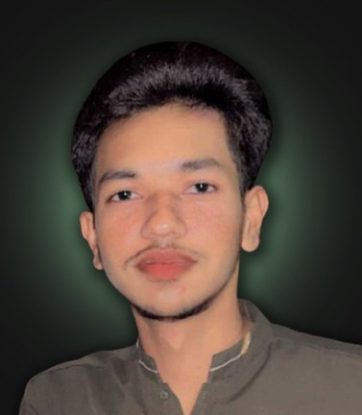
MUHAMMAD

AHAD GOHAR
GRAPHI C DESI GN

Summary

Creative and detail-oriented Graphic Designer with experience in visual design, branding, and digital content. Skilled in creating designs that communicate ideas clearly and attractively.

Education

Government College University Hyderabad (Undergraduate)

Bachelor of Chemistry CGPA: 3.39 as per 2nd Year

About Me
I am a graphic designer who enjoys creating clean and eye-catching designs to bring ideas to life.

Contact

F.G Degree College Hyd Cantt
Pre-Engineering

Grade: A
+92-3297026513


ahadgohar10@gmail.com

Govt. S.K Rahim High School
Science Group
Grade: B
Hyderabad, Sindh, Pakistan @ahadgohar


Work Experiences
Skills

Graphic Design

Local Market
2026 Jan - May

Tools

Adobe Photoshop Adobe illustrator Figma
Remotely Intern
Developed custom designs for client such as social media posts and UI design
UI/UX Design Branding Social Post Packaging

Languages

English
Urdu

Fluent
Fluent

Punjabi Fluent

